Golden–Thompson inequality

Intro

A inequality about trace with exponential of matrix.

Statement

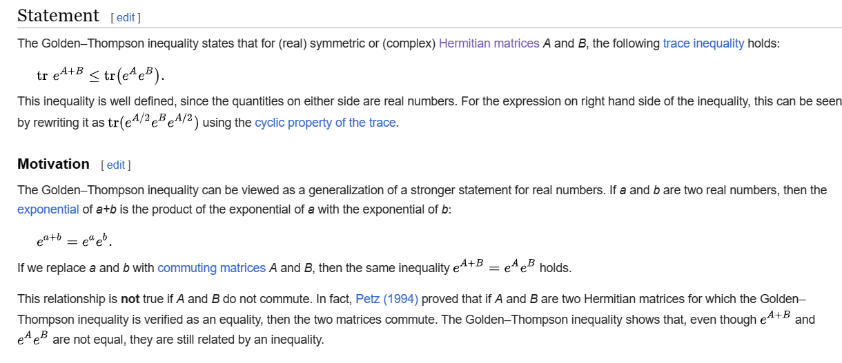

Proof



Ref

[Golden–Thompson inequality - Wikipedia](https://en.wikipedia.org/wiki/Golden%E2%80%93Thompson_inequality)